**DAILY ONLINE ACTIVITIES SUMMARY**

|  |  |  |  |  |  |  |  |  |
| --- | --- | --- | --- | --- | --- | --- | --- | --- |
| **Date:** | **18/05/2020** | | | | | **Name:** | **SPOORTI S DAROJI** | |
| **Sem & Sec** | **4th SEM. & ‘B’ SEC.** | | | | | **USN:** | **4AL18CS088** | |
| **Online Test Summary** | | | | | | | | |
| **Subject** | | **COMPLEX ANALYSIS,PROBABILITY AND STATISTICAL METHODS** | | | | | | |
| **Max. Marks** | | **30** | | **Score** | | | - | |
| **Certification Course Summary** | | | | | | | | |
| **Course** | **PYTHON FOR MACHINE LEARNING** | | | | | | | |
| **Certificate Provider** | | | **Greatlearning**  **academy** | | **Duration** | | | **5 Hrs.** |
| **Coding Challenges** | | | | | | | | |
| **Problem Statement 1:** **Given an array of distinct integers .The task is to count all the triplets such that sum of two elements equals the third element.**  **Problem Statement 2: Write a C program to check whether the two strings are Anagram or not.** | | | | | | | | |
| **Status: 1 executed.** | | | | | | | | |
| **Uploaded the report in Github** | | | | | **Yes** | | | |
| **If yes Repository name** | | | | | **Lockdown Coding** | | | |
| **Uploaded the report in slack** | | | | | **Yes** | | | |

**Online Test Summary: 18MAT41 online test was scheduled from 9:30 am t0 10 am And the test scores are not yet received .The portion for the IA was 4th module there were 30 questions and the time assigned was 30minutes the questions were MCQ type.**

**Online Certification course Summary: I have taken my Online Certification Course in Greatlearning academy the course which I have opted is Python for Machine Learning. Course contains videos, tutorials, assessments and quiz. Today I have gone through the python introduction and I came to know that python is an easy to learn , powerful programming language. We can also use python when our data analysis task needs to be incorporated into a production database. But being a full-fledged programming language, it’s a great tool to implement algorithms for production use.**

**In this video I learned what exactly is python programming language and what is the difference between two well-known languages Python and R. I also learned that python is an open source and there are tons of packages freely available and there are many python IDE’s like pycharm, jupyter notebooks, spyder etc. In the upcoming sessions I'll be going to know about jupyter notebooks and Anaconda installation.I learned step by step procedure to install anaconda on my system.**

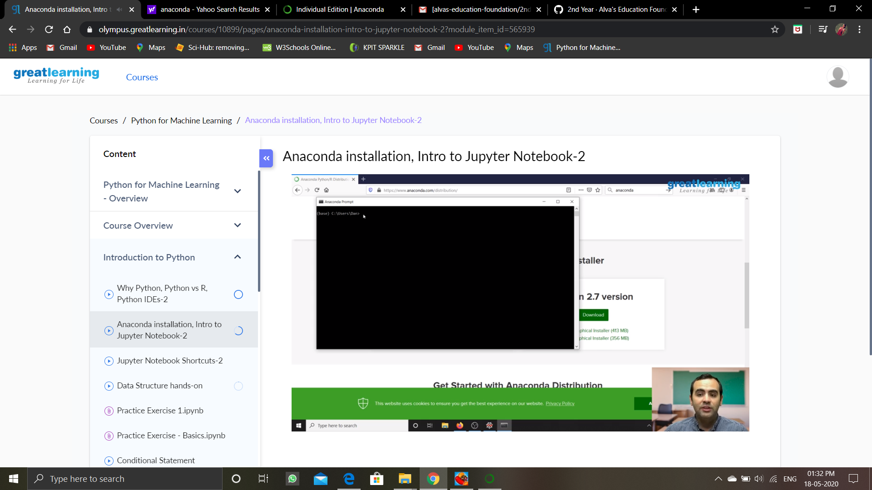

**Online Coding Summary: Today I received two programs from prof.Venkatesh CSE Dept. The two programs were i) to count triplets and ii) to check the given strings are anagram or not. I have written one program and uploaded it to my Github repository.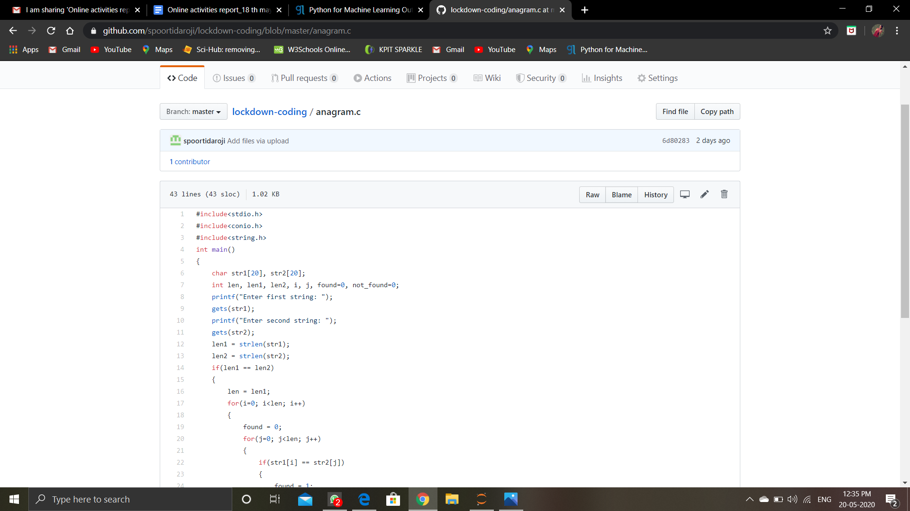This is my repository snapshot. I have uploaded the anagram program.**